PlaceCom

Debunking Placement Myths: Insights from Ashoka’s Data (2021–2024)



Index

Glossary…………………………………………………………………………………………….3

Methodology………………………………………………………………………………………4

Myth 1: “Only students with the highest CGPAs get placed.”....................... 5

Myth 2: “Placements are only for certain majors.”......................................6

Myth 3: “Companies only hire from specific states or cities.”......................7

Myth 4: “High CTCs only go to STEM students.”..........................................9

Myth 5: “Placements have been declining year on year.”............................10

Glossary

Term | Meaning
CTC (Cost to Company) | The total annual compensation offered by an employer, including fixed pay, variable pay, bonuses, and benefits. Reported here in salary bands (e.g., 9–12 LPA, 12–15 LPA).
LPA (Lakhs Per Annum) | A unit of annual salary measurement in India, where 1 LPA = ₹100,000 per year.
CGPA (Cumulative Grade Point Average) | A measure of academic performance on a 4.0 scale at Ashoka University.
Latin Honours | Academic distinctions awarded based on CGPA thresholds: [Summa Cum Laude: ≥ 3.9, Magna Cum Laude: ≥ 3.75, Cum Laude: ≥ 3.6]
Placement Cycle | The annual recruitment process organized by the Career Development Office (CDO), covering undergraduate, postgraduate, and YIF cohorts.
Sector | Broad industry categories where students are placed, e.g., Consulting, Finance, FMCG, Technology, Development, etc.
Major | The primary academic discipline pursued by a student during their undergraduate studies at Ashoka (e.g., Economics, Political Science, Computer Science).
YIF (Young India Fellowship) | A one-year multidisciplinary postgraduate diploma program at Ashoka University.
“Other States” | A category in the placement data capturing students’ state of origin beyond the top five represented states (Delhi, Maharashtra, Haryana, Uttar Pradesh, Karnataka).
Exceptional / Very High / High Salary Bands | Salary categories used in the report to classify offers:  Exceptional: > 15 LPA  Very High: 12–15 LPA  High: 9–12 LPA

Methodology

Data Sources: Placement data for this analysis were obtained from the Career Development Office (CDO) and Superset for the years 2021–2024. The records include information from Undergraduate, Postgraduate, and Young India Fellowship (YIF) cohorts, covering key details such as academic major, CGPA, state of origin, placement sector, recruiting company, and Cost-to-Company (CTC).

Sampling: The dataset includes all students who successfully secured placements during the 2021–2024 cycles. In total, the data spans over 1,100 placement outcomes across four cycles, providing comprehensive coverage and enabling robust analysis.

Variables Analyzed: The analysis focused on several dimensions of the placement data. Academic performance was examined through CGPA distributions and Latin Honours distinctions, while representation across disciplines was studied to understand major-wise trends. Geographic diversity was assessed based on students’ states of origin, and salary trends were explored by categorizing offers into High, Very High, and Exceptional CTC bands. Additionally, year-on-year placement totals were considered to identify broader trends.

Approach: Data was aggregated, visualized, and compared to systematically examine recurring myths about placements. Each myth was evaluated using descriptive statistics, including percentages, counts, and charts, to contrast perception with reality. The analysis emphasizes accessibility, ensuring that insights remain clear and student-friendly.

Limitations: The placement figures included in this analysis reflect only students who participated in the placement process. Those pursuing higher education, gap years, or self-driven career paths are not represented. Salary bands are based on offered CTCs, which may differ from actual take-home pay, and geographic categorization relies on self-reported states of origin, which may not account for students’ mobility during schooling. While the data covers four placement cycles, external factors such as economic shifts and sectoral hiring trends could also influence outcomes beyond university-level factors.

1. “Only students with the highest CGPAs get placed.”
- The placement data shows that this is not true.
- Looking specifically at students who pursued their undergraduate degrees at Ashoka, 51% of students who were placed did not have any Latin Honours distinction (CGPA < 3.6).
- A significant proportion also came from the 3.0–3.5 CGPA band (26.4%), compared to only 11.5% in the Summa Cum Laude category (CGPA ≥ 3.9).
- This clearly demonstrates that strong placements are not restricted to students with the very highest grades. Recruiters consider diverse skills, internships, and competencies in addition to academics.
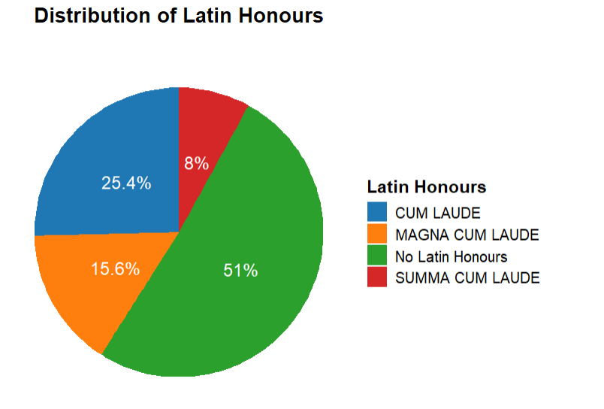

2. “Placements are only for certain majors.”
- While Economics accounts for 48% of the placed Ashoka undergrads, the data shows that students from across the academic spectrum are represented.
- For instance, Psychology majors made up 13.41%, Computer Science majors 11.42%, Political Science majors 8.11%, and English majors 3.81% of placed undergraduate students.
- Smaller majors, such as Sociology/Anthropology (2.65%), History (1.9%), and even Physics (0.9%), are also featured.
- This proves that employers hire from a wide variety of disciplines. The high representation of Economics stems partly from its large cohort size and the higher proportion of students who sit for placements, not because opportunities are exclusive to them.

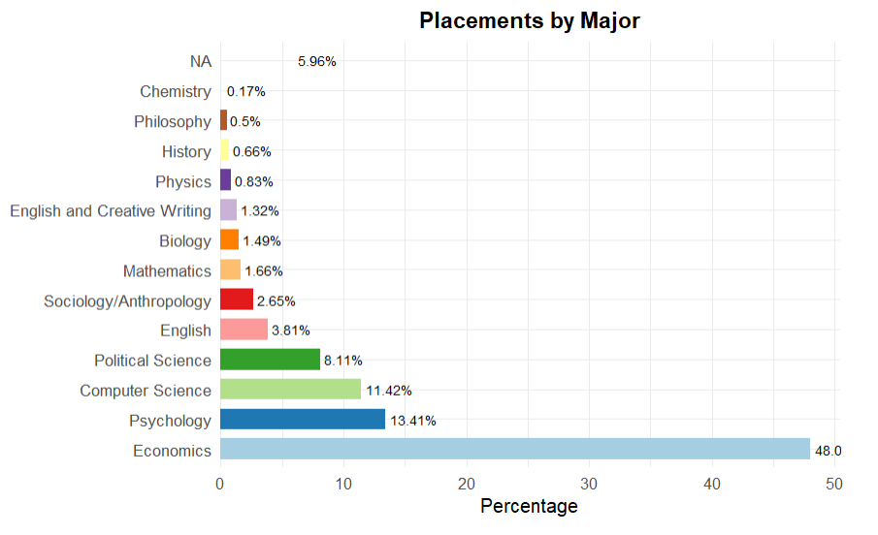

3. “Companies only hire from specific states or cities.”
- Geographic diversity is evident in the placement outcomes.
- While Delhi (19.4%), Maharashtra (12.6%), Haryana (11.7%), Uttar Pradesh (10.1%), and Karnataka (9.6%) together account for a sizeable share, a striking 36.5% of placed UG/Masters/YIF students come from “Other States” spread across India.
- The heat map visualization further highlights how placements span almost every region, including Tamil Nadu, West Bengal, and Punjab.
- This disproves the myth: recruiters do not confine hiring to a handful of metros but engage with students from diverse geographic backgrounds.
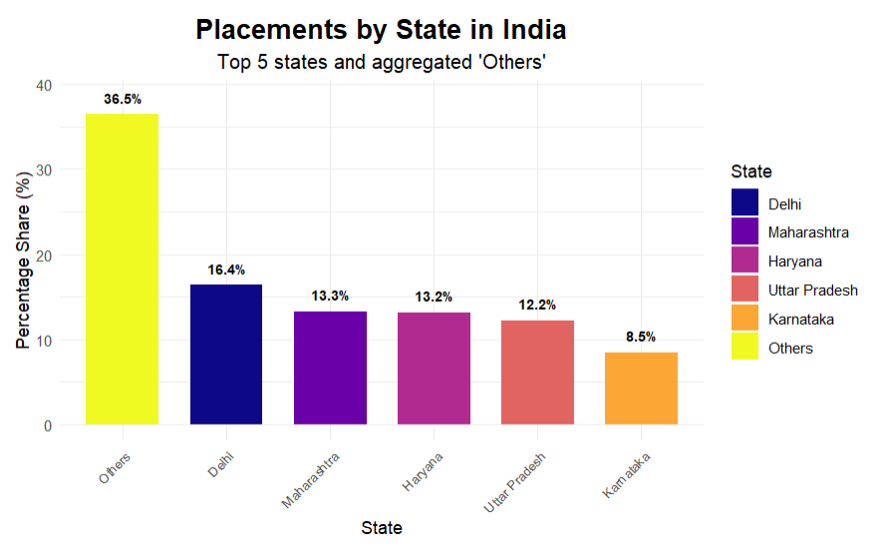

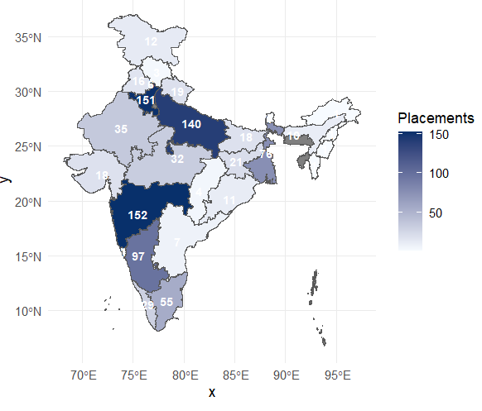

4. “High CTCs only go to STEM students.”
- The salary distribution data shows otherwise.
- In the Very High band (12–15 LPA), 93% of placed UG students came from Non-STEM majors, and in the High band (9–12 LPA), 87.4% were Non-STEM.
- Even in the Exceptional band (>15 LPA), 11.7% of hires were Non-STEM.
- When comparing Economics and Non-Economics, Non-Economics students actually secured the majority of Exceptional placements (77%) and Very High placements (65%).
- Clearly, high-paying jobs are spread across diverse fields and not restricted to STEM or Economics majors.

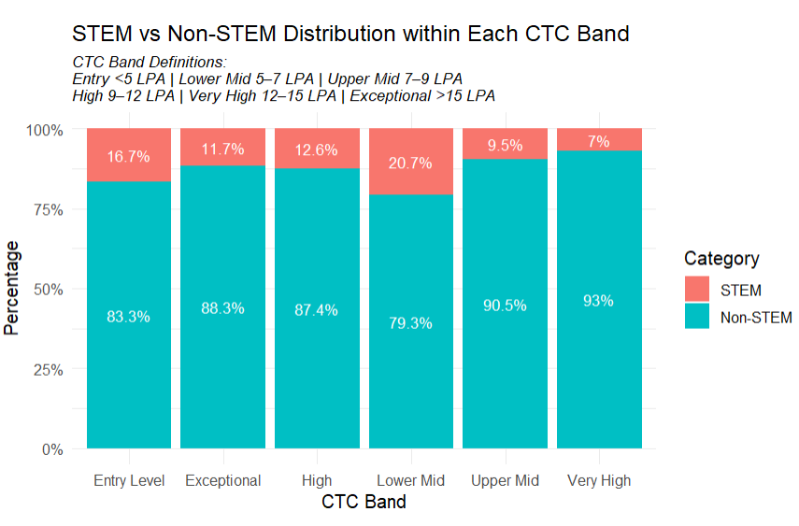

5. “Placements have been declining year on year.”
- The year-wise placement totals disprove this claim.
- Placements were 289 in 2021, dipped slightly to 280 in 2023, but rebounded sharply in 2024 to 320—the highest across the four-year period.
- This trend shows natural fluctuation, not decline.
- The overall trajectory demonstrates resilience and growth in opportunities, especially with the 2024 surge.
